**Sprint Schedule**

**COMP3000**

**Computing Project**

**2022/2023**

**Project Title**

ChessAI – A Chess Practice Tool

**Project Lead Developer / Manager**

Callum Organ

**Project Supervisor**

Lingfen Sun

**Links**

Source code:<https://github.com/ORG4N/ChessAI>

Kanban board: <https://trello.com/b/TubtD2KW/chessai>

|  |  |  |  |
| --- | --- | --- | --- |
| Document Revision History | | | |
| **Date** | **Ver.** | **Description** | **Changed by** |
| 29/01/2022 | 1 | Document created. | Callum Organ |
| 31/01/2022 | 2 | Added semester two roadmap and conclusions. | Callum Organ |

**Document Overview**

Within sprints 3 and 5 it was noted that a major complication within the project relates to low productivity within the time approaching and succeeding assignments and their deadlines. The issue arising from this is that sprint items are overplanned and little work is done, or none at all, and the unfinished jobs are pushed to the next sprint. This results in the project suffering from being ‘behind’ schedule.

This overall objective of this document is to map the sprints within the second semester (from sprint 6 onwards) and justify breaks in between sprints as well as to highlight important deadlines to be aware of.

In the first section, the first semester’s challenges/issues are discussed and suggestions into how to improve productivity are made. A roadmap of how the sprints were scheduled is drawn.

In the second section, the second semester’s roadmap is formed with the previous section’s established concerns in mind. The improvements of this schedule are highlighted.

In the third section, the two roadmaps are merged to provide an outlook into the overall roadmap of all sprints throughout the project development lifecycle.

In the final section, conclusions are made to reaffirm how semester one’s troubles have been overcome.

First Semester 3

Sprint Roadmap 3

Challenges 3

Second Semester 4

Sprint Roadmap 4

Improvements in Scheduling 4

Final Roadmap 5

Conclusions 6

First Semester

At the time of creating this document, the first semester has just ended and therefore this section of the report highlights the issues encountered with project management in semester one.

## Sprint Roadmap

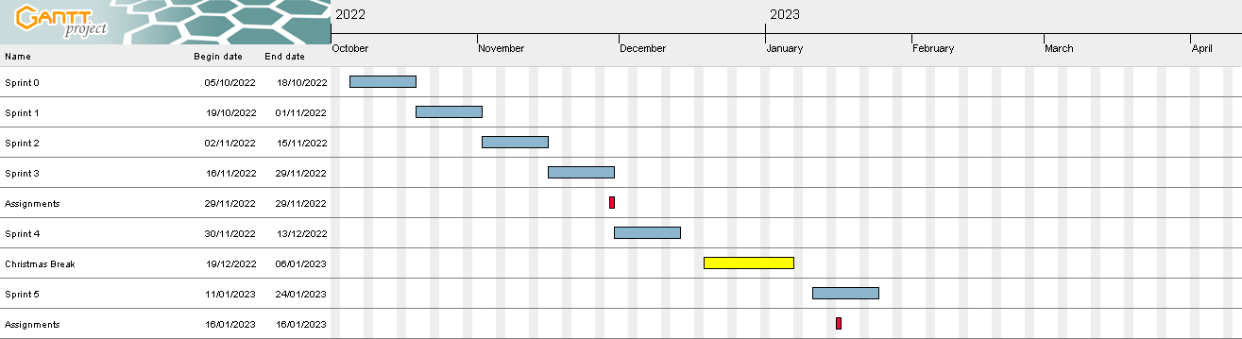

This figure shows a roadmap for all sprints that occurred within semester one, where:

* Blue boxes represent sprints.
* Red boxes represent assignment deadlines.
* Yellow boxes represent vacations/breaks.

## Challenges

As seen within the figure above, some sprints overlap with assignment deadlines (such as, sprints #3 and #5). The complications that this overlap causes is that assignments are a higher priority than a sprint and must be urgently worked towards completing. Therefore, as the focus of the weeks preceding deadlines is the assignment for that specific deadline, the jobs set to be completed within the conflicting sprints don’t end up being worked towards.

This issue sprouted from a lack of foresight when setting sprint dates – mainly because the proposed Gantt chart within the *Project Initiation Document* is of low quality and does not highlight important dates. Also, the lack of a pre-planned sprint schedule/overview document resulted in I, the project lead, just creating sprints linearly, one after the other.

Overall, to ensure that these problems do not re-surface within the second semester, a sprint roadmap will be made prior, similar to the above one, wherein assignment deadlines and vacations are highlighted. However, the roadmap for semester two will solve the conflict issues in semester one’s roadmap by removing the overlap and adding breaks, where needed, between sprints.

Second Semester

As of creating this document, the second semester has not started yet, and in line with the previously outlined challenges within semester one, I, the project lead, will try to solve those issues by preplanning the sprints within semester two around assignment deadlines within the semester two modules.

## Sprint Roadmap

This figure shows a roadmap for all sprints that occurred within semester two, where:

* Blue boxes represent sprints.
* Red boxes represent assignment deadlines.
* Yellow boxes represent vacations/breaks.

## Improvements in Scheduling

Whilst there are overall less sprints planned for semester two, I anticipate that these sprints will be more productive. Within semester one there were lots of sprints which might seem good, but the conflicts with assessment deadlines meant that sprints were often very unproductive and redundant (nothing was accomplished during the sprint duration).

Within the figure above it can be seen that in the time preceding assessments, there are empty blocks of ‘space’ which is expected to be the time set to undertake the other module’s assignments. For example, the first set of assignments will be completed within the two weeks before the deadline, and the second set of assignments will most likely be completed within Spring break (and there are a few days’ worth of free time before the deadline).

Overall, these sprints should all be productive and within them the project will be the focus, rather than the external modules.

# Final Roadmap

This figure shows a roadmap for all sprints that occurred within the entire academic year, where:

* Blue boxes represent sprints.
* Red boxes represent assignment deadlines.
* Yellow boxes represent vacations/breaks.
* Purple boxes represent semesters.

# Conclusions

Overall, the main problem established within semester one was that there was a lack of scrutiny and foresight when planning sprints – as such there were sprints directly after another in a clumsy fashion, as well as conflicts with other module’s assessment deadlines. It was very hard to balance all three modules within the same time, wherein high priority features were planned to be created within the ChessAI project alongside completing two module’ worth of assignments, which were also high priority.

Therefore, within semester two, I, the project lead, have planned the roadmap around the vacations and assessment deadlines, so as to remove these conflicts and alleviate the stress on myself. The overall goal is to reduce the burden on myself and increate productivity by dedicating time to the project and the modules separately.